VISA Mainframe CI/CD – TO‑BE Architecture & YAML Implementation Guide
Document Version: 1.0
Prepared By: DevOps Engineering Team
Last Updated: 18-02-2026

TABLE OF CONTENTS
- Introduction
- Purpose of This Document
- Audience
- Current State (As‑Is Overview)
- TO‑BE Architecture Overview
- High-Level System Architecture
- Component-Level Architecture
- CI/CD Logical Flow
- Source Code Management Structure
- YAML Design Strategy
- YAML File Structure Standards
- Language-Specific YAML Design
- BMS YAML Design
- Non-Buildable Component Handling
- Build Flow – Detailed Execution Steps
- Artifact Management Strategy
- Environment Strategy (Sandbox, UAT, PROD)
- Configuration Management Approach
- Error Handling & Logging
- Security Considerations
- Performance Considerations
- Setup Guide for New Joiners
- VS Code Configuration Steps
- Zowe Configuration Steps
- YAML Validation & Testing Steps
- Demo Execution Guide
- Assumptions & Constraints
- Risks & Mitigation
- Ownership & Maintenance Model
- Appendix – Screenshot Placeholders & Reference Sections

1. Introduction
This document describes the TO‑BE architecture and YAML implementation strategy for the VISA Mainframe CI/CD initiative.
It provides both: - Architecture-level understanding - Practical implementation guidance
The objective is to ensure that any new engineer, architect, or stakeholder can understand how the CI/CD system is designed and how YAML build configurations operate.

2. Purpose of This Document
The purpose of this document is to:
- Explain the TO‑BE architecture for Mainframe CI/CD
- Describe YAML design and structure
- Document build execution flow
- Provide onboarding steps for new team members
- Support demo and knowledge transfer sessions
This document is technical and implementation-focused.

3. Audience
This document is intended for:
- DevOps Engineers
- Mainframe Developers
- CI/CD Engineers
- Technical Architects
- Support Engineers

4. Current State (As‑Is Overview)
Currently:
- YAML files exist locally in VS Code
- Build definitions are language-based
- No centralized pipeline execution yet
- Architecture is validated in Sandbox environment
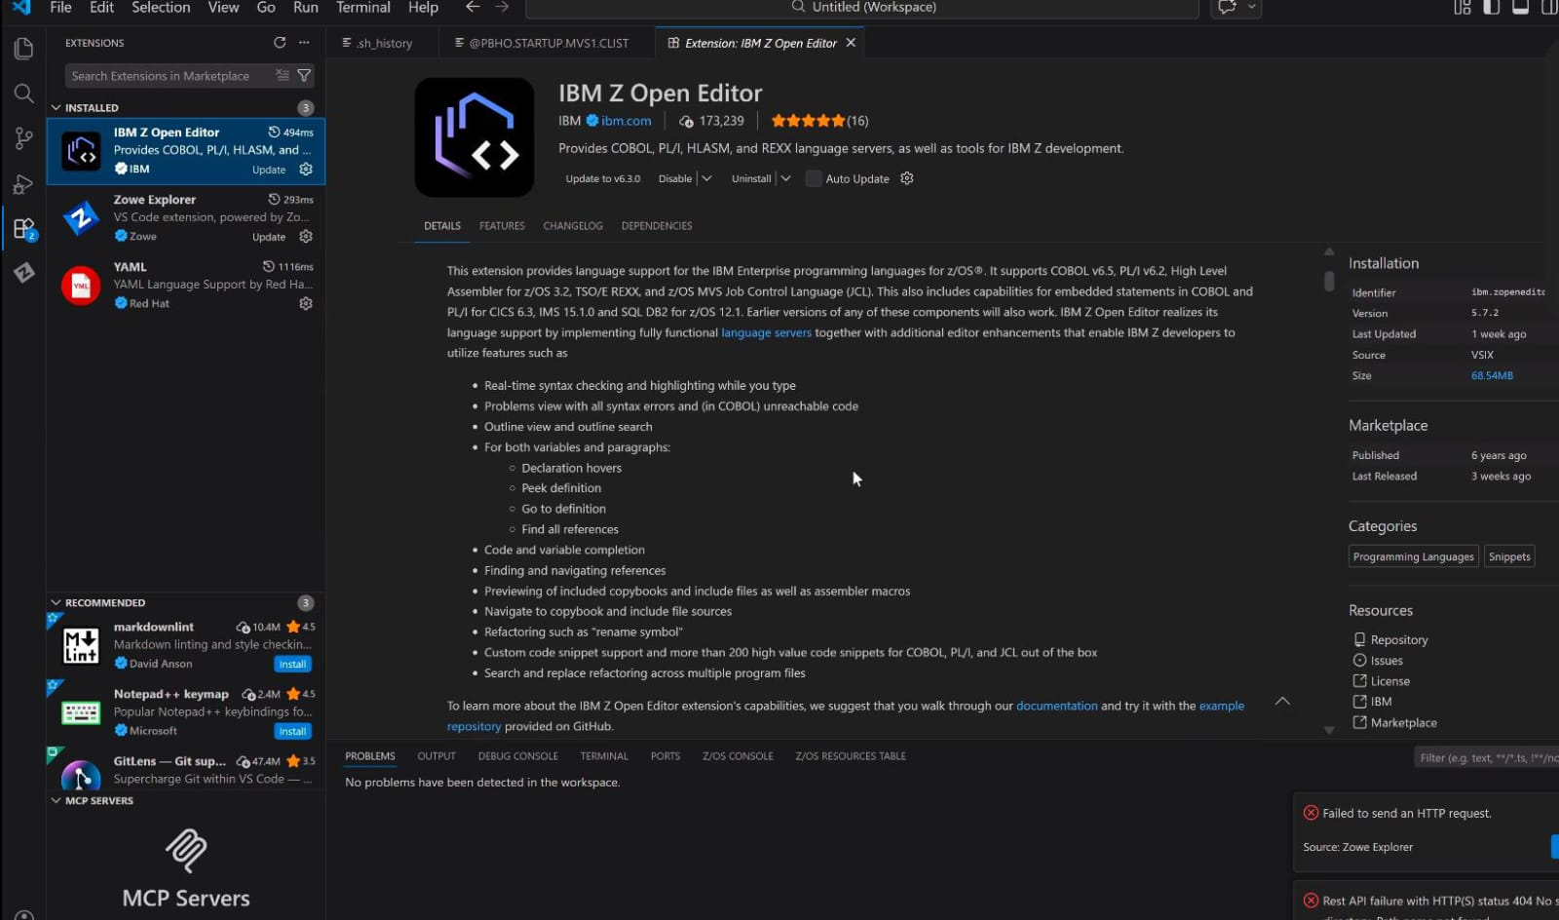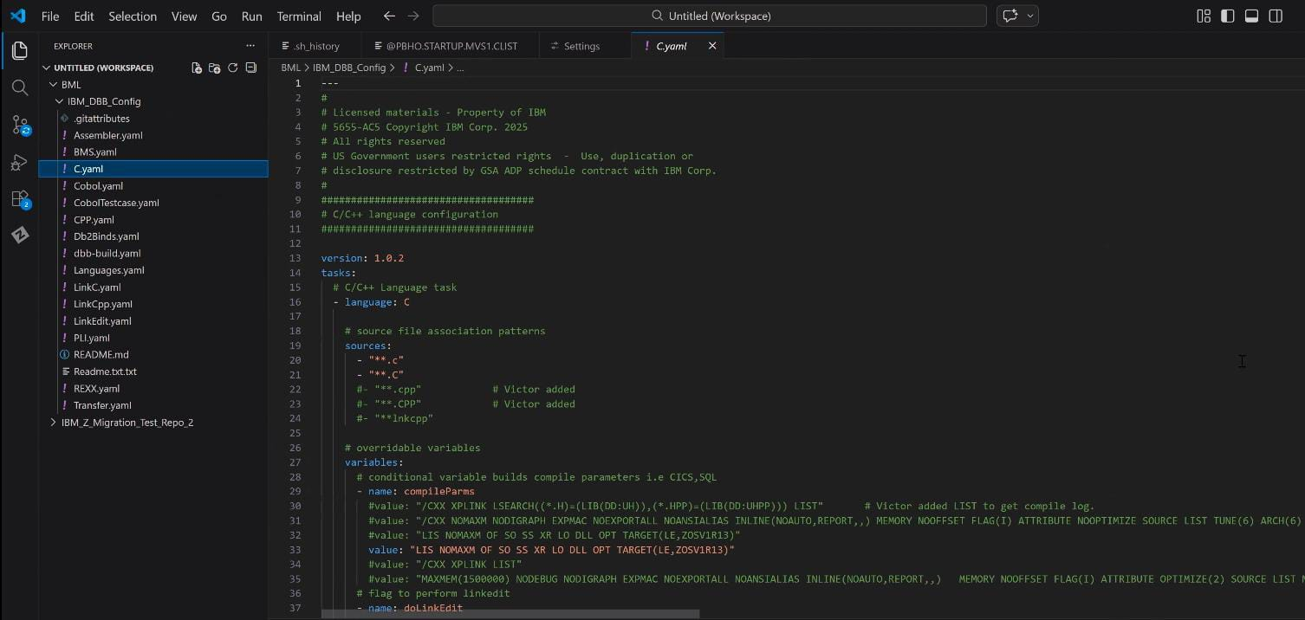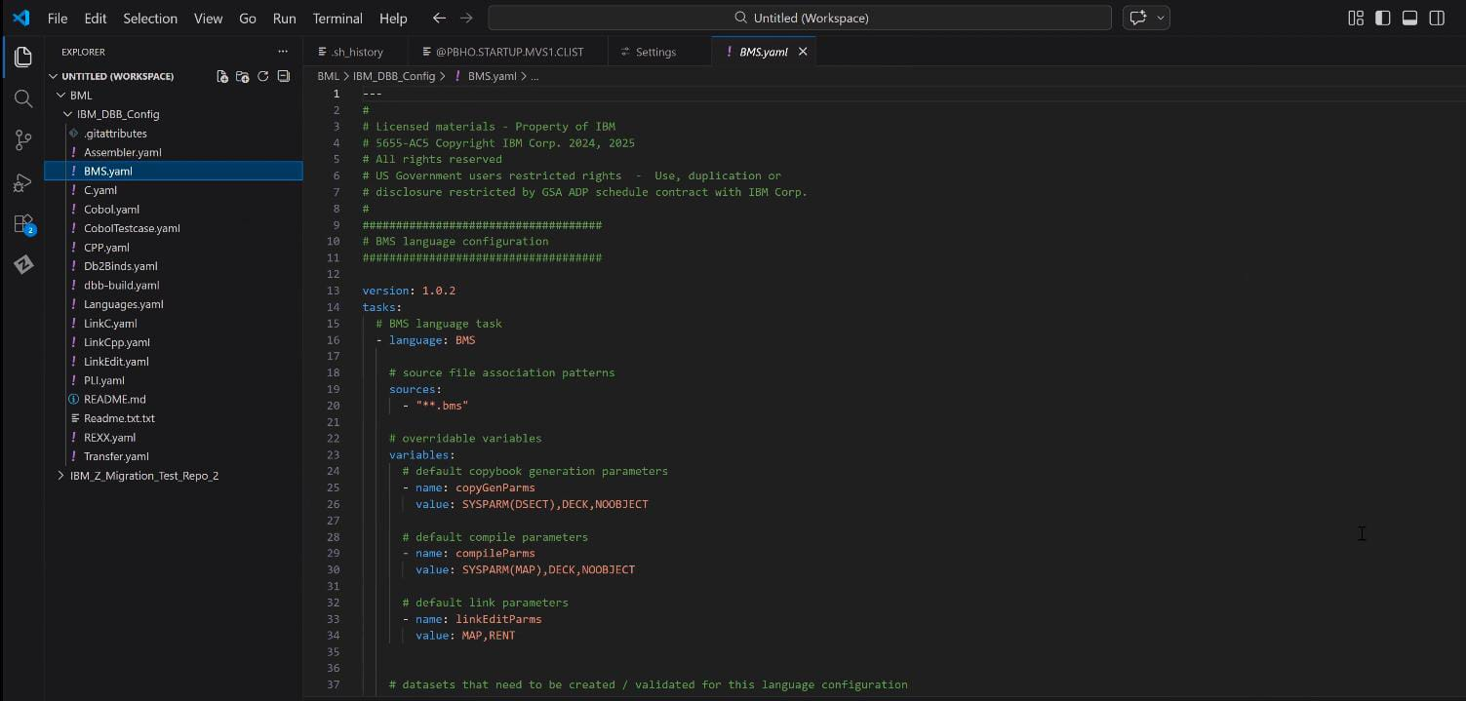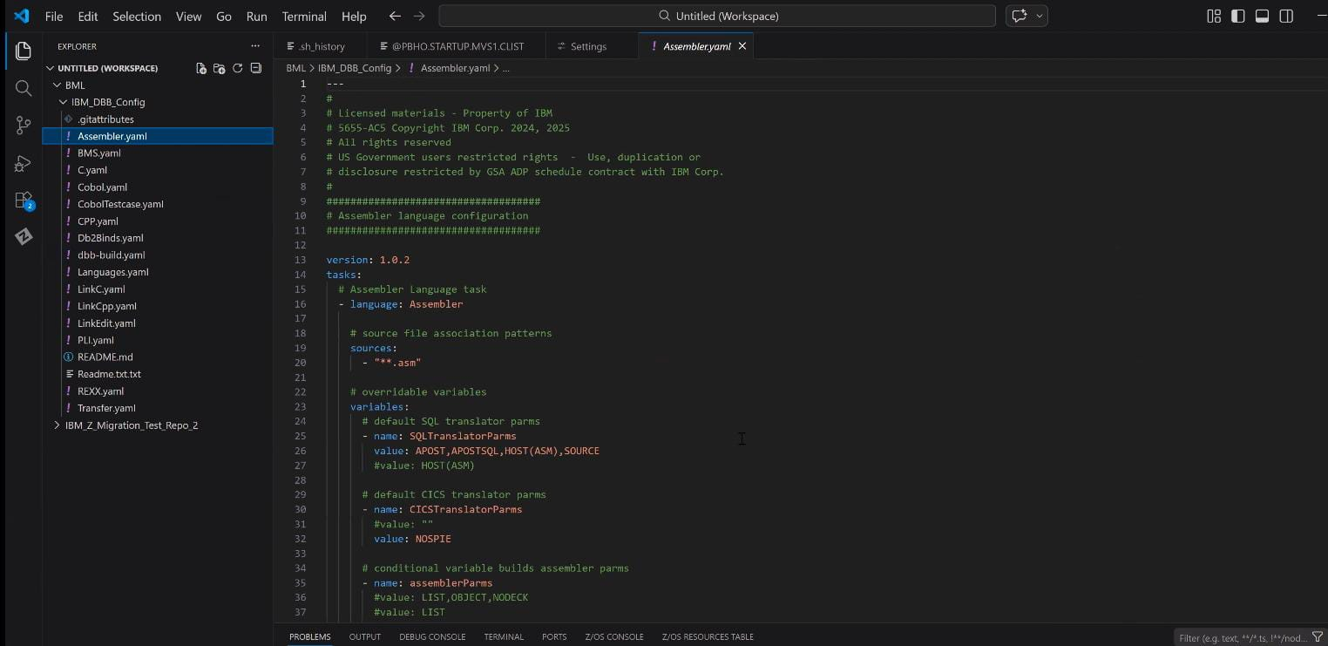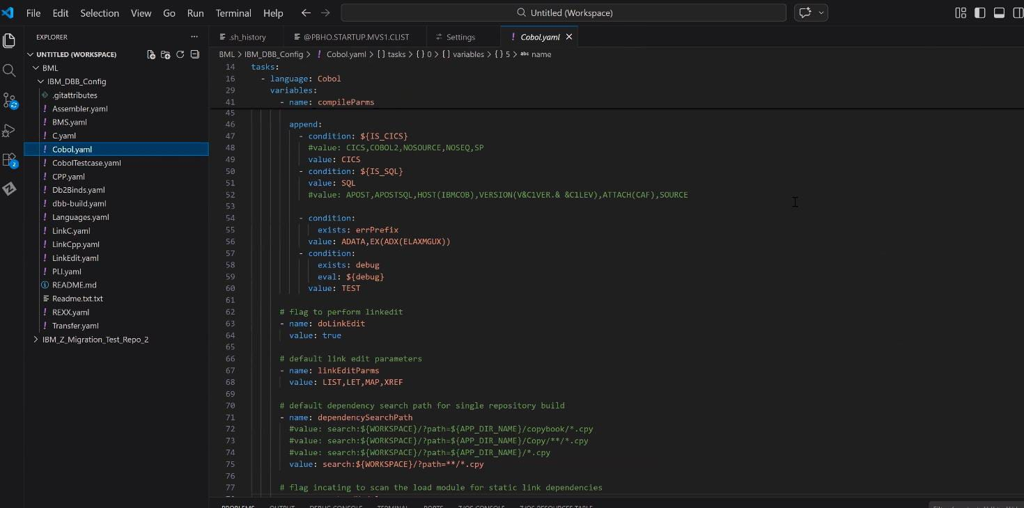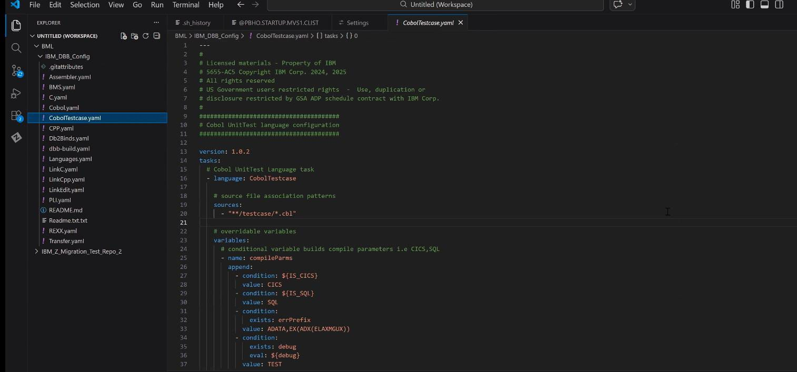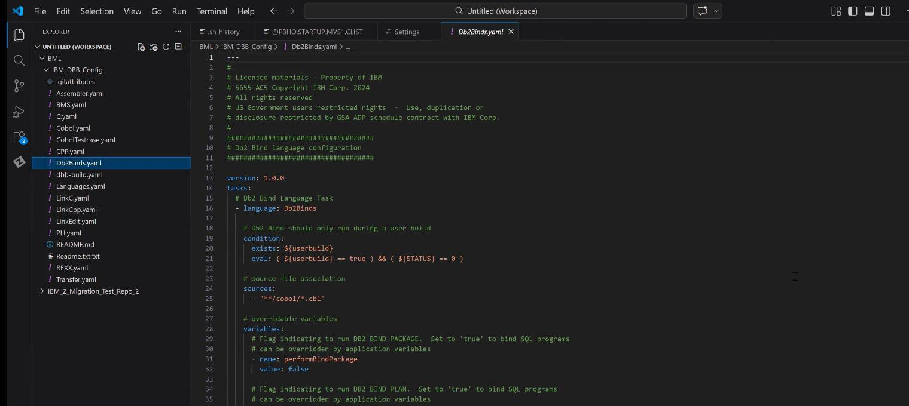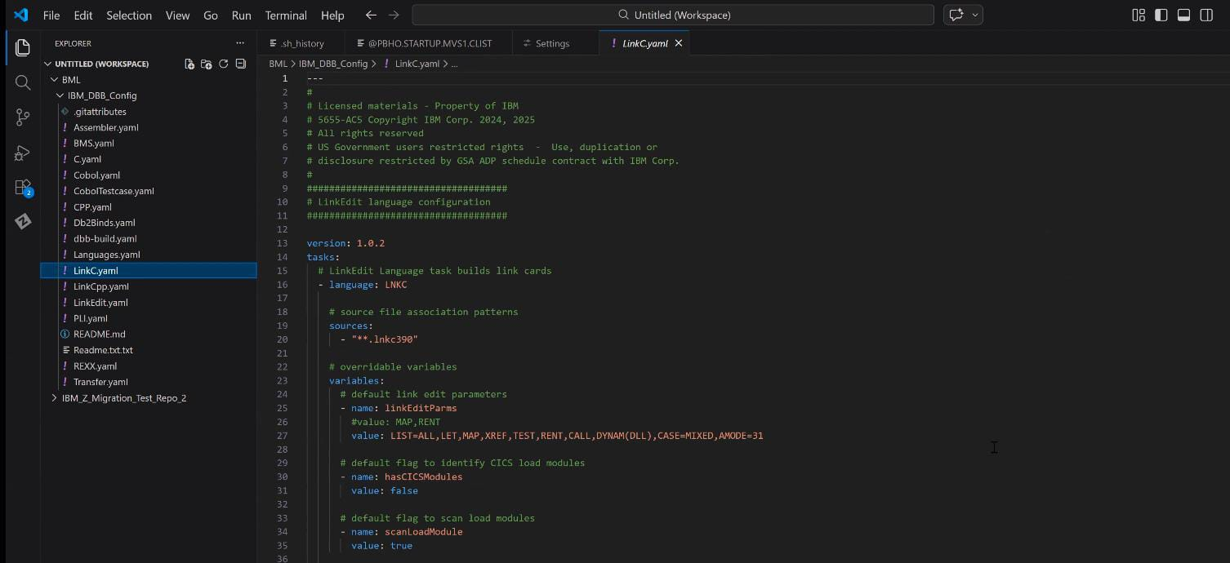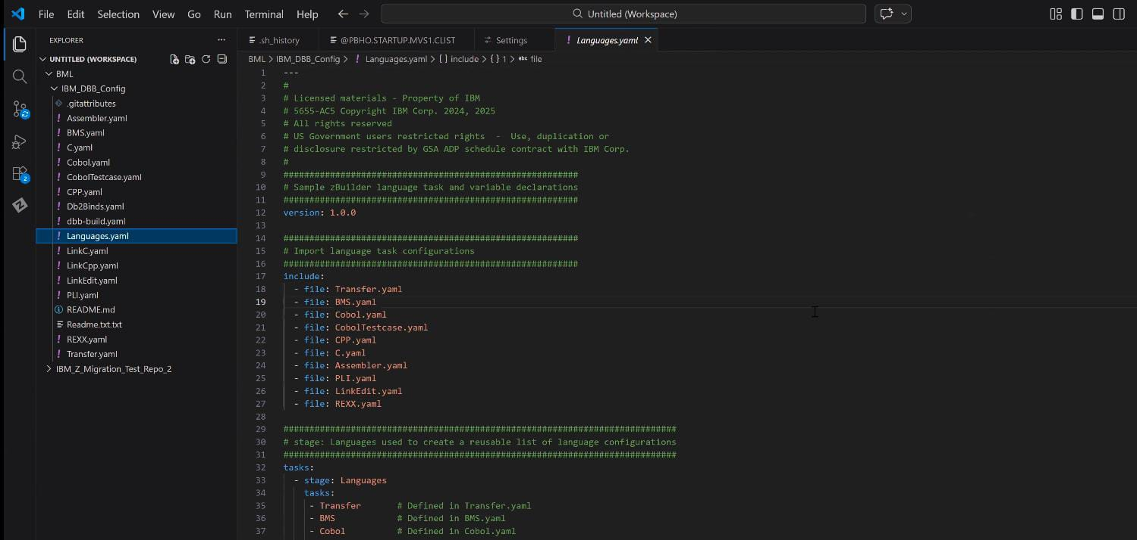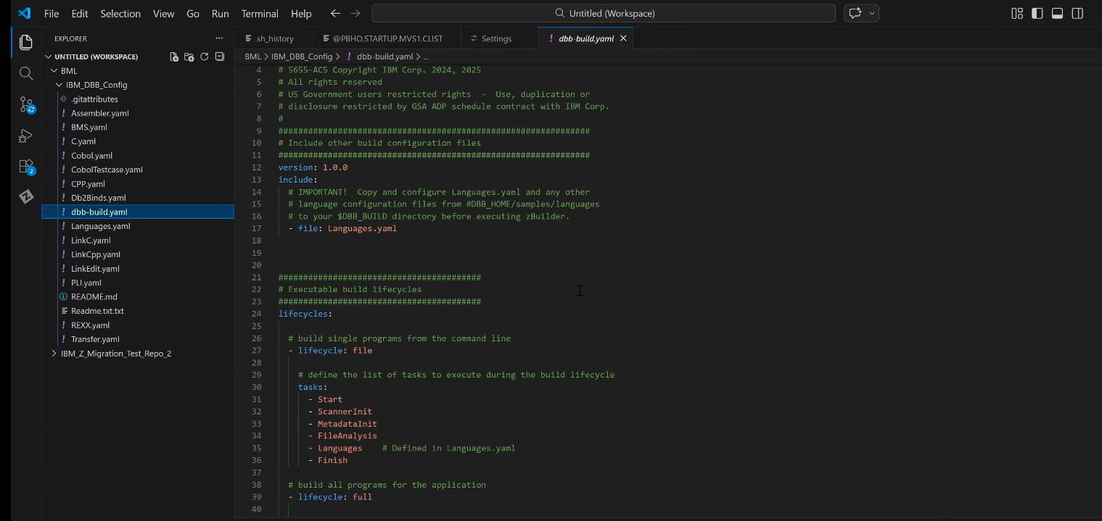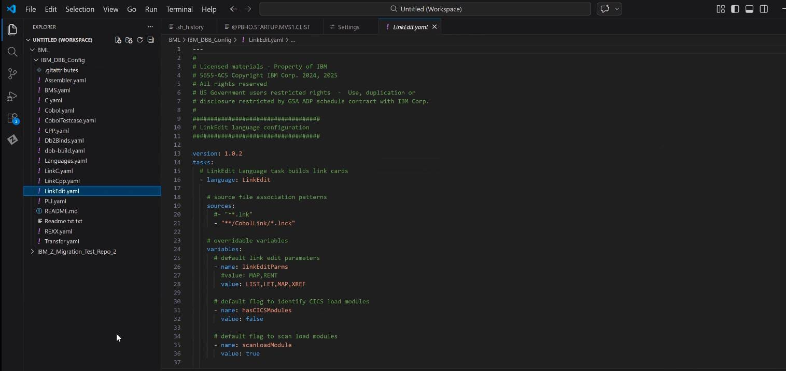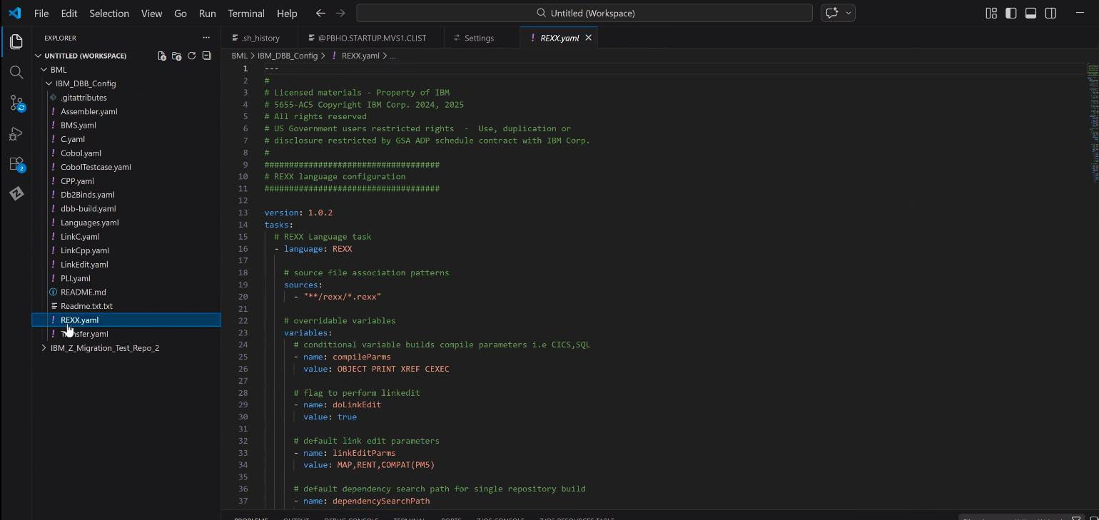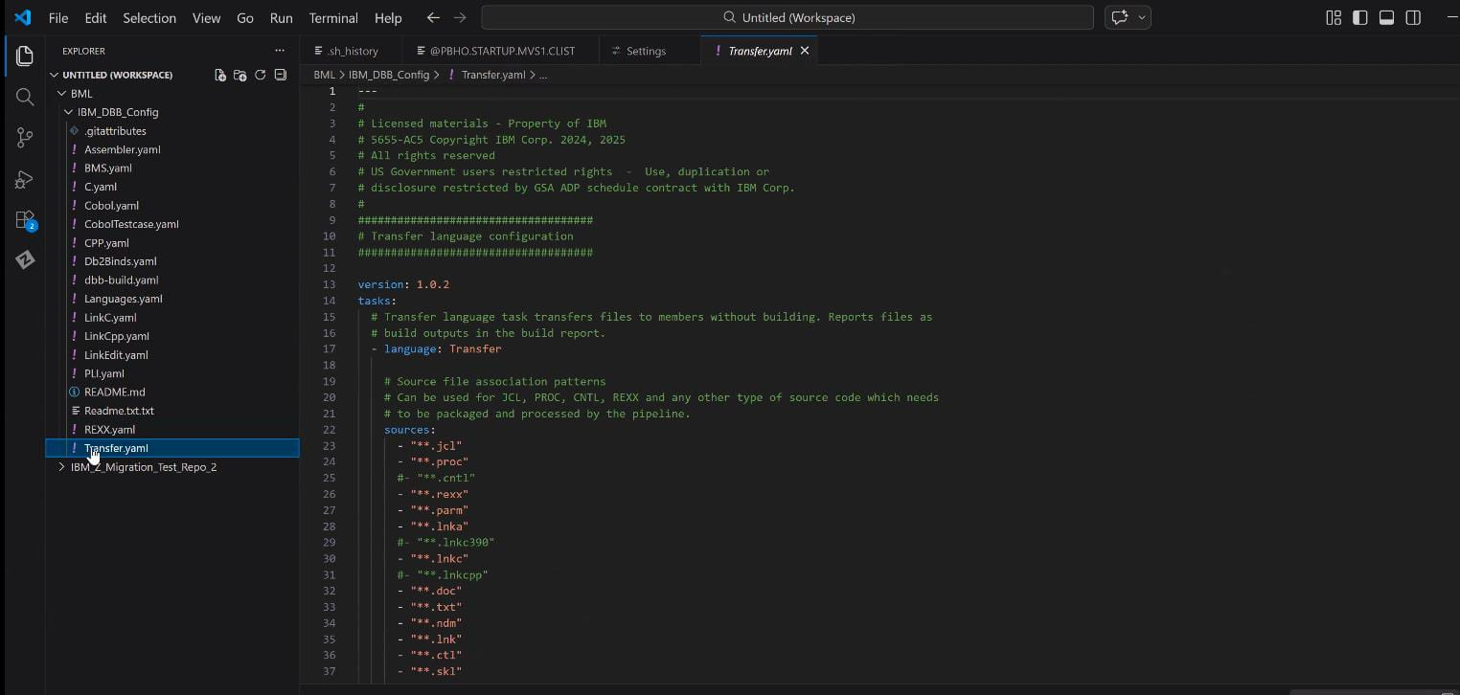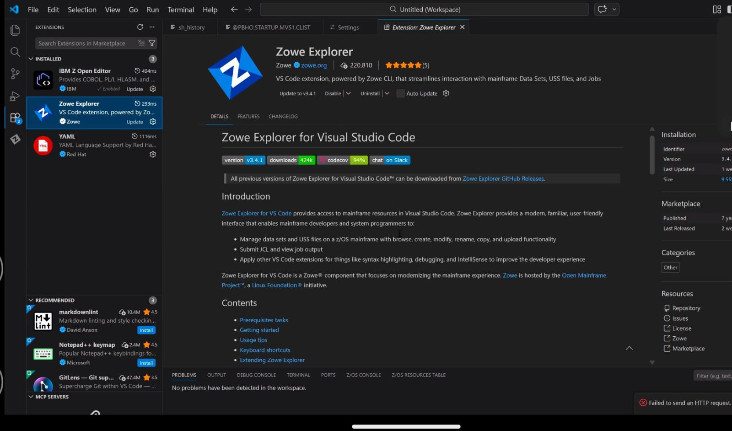

5. TO‑BE Architecture Overview
The TO‑BE architecture introduces:
- Standardized YAML-driven builds
- Centralized CI/CD orchestration
- Automated artifact generation
- Environment-specific configuration reuse
The system follows modular design principles.

6. High-Level System Architecture
Components:
- Developer Workstation (VS Code)
- Mainframe (z/OS)
- CI/CD Orchestration Layer
- Artifact Repository
- Target Deployment Environments

7. Component-Level Architecture
Each component is responsible for:
Developer Environment
- Code editing - YAML configuration
Mainframe
- Compilation - Link-edit
CI Layer
- Trigger builds - Execute YAML logic
Artifact Store
- Store compiled load modules

8. CI/CD Logical Flow
Step 1: Developer updates source
Step 2: YAML determines language type
Step 3: Compile process executed
Step 4: Link-edit executed
Step 5: Artifact generated
Step 6: Artifact published
📸 Screenshot Placeholder: Build console output

9. Source Code Management Structure
Repository contains:
- Source files
- YAML definitions
- Configuration references
Directory Structure Example:
/src
/yaml
/config

10. YAML Design Strategy
YAML design principles:
- Single responsibility per YAML
- Language-specific configuration
- Environment-independent logic
- Reusable compile rules

11. YAML File Structure Standards
Each YAML includes:
- Version declaration
- Task definition
- Source patterns
- Compile parameters
- Output definitions

12. Language-Specific YAML Design
Supported Languages:
- COBOL
- Assembler
- C
- C++
Each YAML handles:
- Source identification
- Compiler invocation
- Parameter passing
- Error stopping logic

13. BMS YAML Design
BMS requires separate handling due to:
- Map compilation process
- CICS screen dependencies
Separate YAML ensures:
- Controlled map generation
- Reusability

14. Non-Buildable Component Handling
Handled components:
- JCL
- REXX
- Copybooks
These are included for dependency management.

15. Build Flow – Detailed Execution Steps
- Source scan
- Language detection
- Compile execution
- Link-edit
- Return code validation
- Artifact packaging

16. Artifact Management Strategy
Artifacts include:
- Object modules
- Load modules
- Logs
Naming convention follows standard format.

17. Environment Strategy
Sandbox
- Development validation
UAT
- Functional validation
Production
- Final deployment
YAML logic remains same across environments.

18. Configuration Management
Environment variables are separated from YAML logic.
This ensures:
- No duplication
- Easy promotion

19. Error Handling & Logging
- Immediate stop on compile error
- Return code validation
- Log storage

20. Security Considerations
- Controlled access to source
- Restricted execution permissions
- No credentials stored in YAML

21. Performance Considerations
Performance measured via:
- Compile time
- Execution duration
No infrastructure-level optimization included.

22. Setup Guide for New Joiners
Step 1: Install VS Code
Step 2: Install required extensions
Step 3: Configure Zowe profile
Step 4: Clone repository
Step 5: Open YAML directory

23. VS Code Configuration Steps
- Install Zowe Explorer
- Configure connection
- Validate connection

24. Zowe Configuration Steps
- Create profile
- Add host
- Add user credentials
- Test connection

25. YAML Validation & Testing
Steps:
- Open YAML file
- Validate syntax
- Execute test build
- Verify return code

26. Demo Execution Guide
For demo:
- Show YAML file
- Explain compile section
- Trigger build
- Show artifact
- Show logs

27. Assumptions & Constraints
- Infrastructure provided externally
- Access managed separately
- Languages limited to defined scope

28. Risks & Mitigation
Risk: Environment delay
Mitigation: Sandbox validation
Risk: Unsupported language
Mitigation: Controlled onboarding

29. Ownership & Maintenance
- YAML maintained by DevOps
- Changes reviewed via approval
- Documentation updated per revision

30. Appendix – Screenshot Placeholders
Add screenshots for:
- VS Code YAML view
- File explorer structure
- Zowe connection
- Build output logs
- Artifact output

